Project Design Phase-II
Data Flow Diagram & User Stories

Date | 31 January 2025
Team ID
Project Name
Maximum Marks | 4 Marks

Data Flow Diagrams:
A Data Flow Diagram (DFD) is a traditional visual representation of the information flows within a system. A neat and clear DFD can depict the right amount of the system requirement graphically. It shows how data enters and leaves the system, what changes the information, and where data is stored.
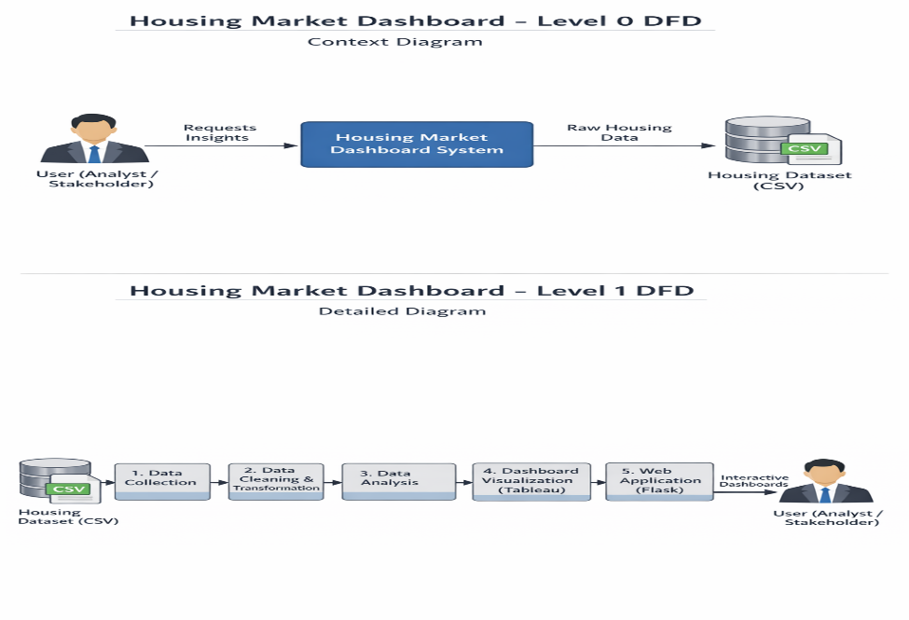
Example: (Simplified)


User Stories
Use the below template to list all the user stories for the product.
User Type | Functional Requirement (Epic) | User Story Number | User Story / Task | Acceptance Criteria | Priority | Release
Student | Registration | VHMTAS-1 | As a user, I can register for the application by entering my email, password, and confirming my password. | User can successfully create an account and access the dashboard | High | Sprint-1
 |  | VHMTAS -2 | As a user, I will receive a confirmation email after registration. | Confirmation email is received and account is verified | High | Sprint-1
 |  | VHMTAS -3 | As a user, I can register using Facebook login. | User can log in and access dashboard via Facebook | Low | Sprint-2
 |  | VHMTAS -4 | As a user, I can register using Gmail login. | User can log in and access dashboard via Gmail | Medium | Sprint-1
 | Login | VHMTAS -5 | As a user, I can log in using my email and password. | User is logged in and redirected to dashboard | High | Sprint-1
 | Dashboard Access | VHMTAS-6 | As a user, I want to view housing market KPIs on the dashboard. | Dashboard displays KPIs correctly | High | Sprint-1
 | Data Visualization | VHMTAS -7 | As a user, I want to view renovation impact on house prices. | Chart loads and shows renovated vs non-renovated prices | High | Sprint-1
 |  | VHMTAS -8 | As a user, I want to see house age distribution. | Pie chart displays age groups clearly | Medium | Sprint-1
 |  | VHMTAS -9 | As a user, I want to compare bedrooms, bathrooms, and floors by house age. | Bar chart shows correct feature comparison | Medium | Sprint-2
Executive | User Support | VHMTAS -10 | As a support executive, I want to help users with dashboard access issues. | User issues are resolved successfully | Medium | Sprint-2
Administrator | Data Management | VHMTAS -11 | As an admin, I want to upload and manage housing datasets. | Dataset is uploaded and reflected in dashboard | High | Sprint-1
 | Dashboard Management | VHMTAS -12 | As an admin, I want to manage dashboard content and visibility. | Dashboard updates are visible to users | Medium | Sprint-2

